**Main Page updates**



Can we please make sure that the zoom in zoom out works please

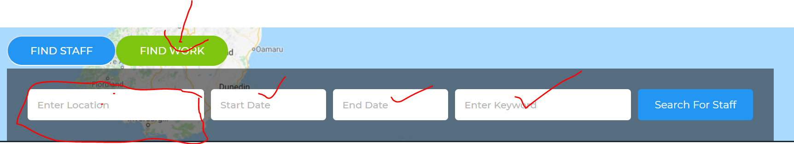

Can the default be set to “find work” on the home page rather than “find Staff”

When you start typing a location can it start to pre-populate place names using goggle

_________________________________________________________

**Blog page** (happy with this page no changes needed)

___________________________________________________________

**Sign in page updates**

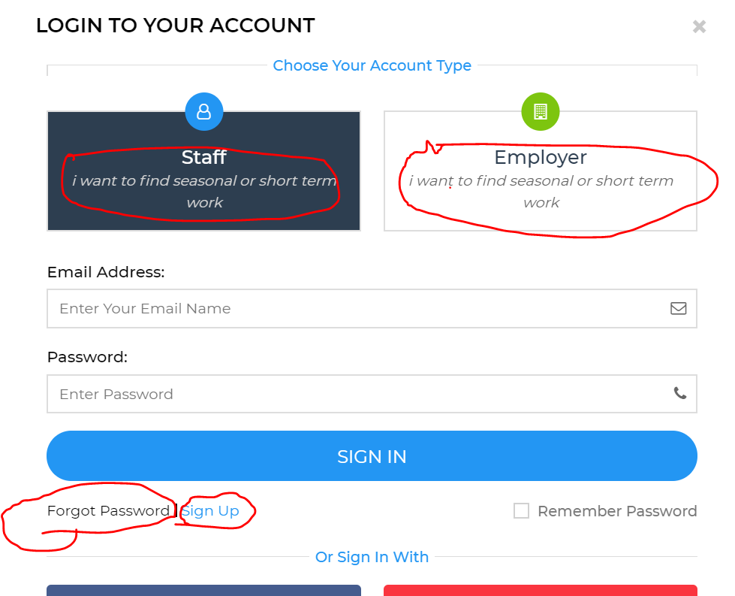

**“staff”** - can the wording be “I am looking for seasonal or short term work”

**“Employer”** – can the working be “I am a looking for staff to fill seasonal or short term jobs”

**Forgot password.** Will this be a link that will send out details to their email to resent password. I would like this to be easy please.

**“Sign up”** ( in blue by the “forgot password) This should be “not a member yet….. Join now” this is when they don’t have an account with us) can we please make sure this process is very clear.

______________________________________________

**Contact us page updates**

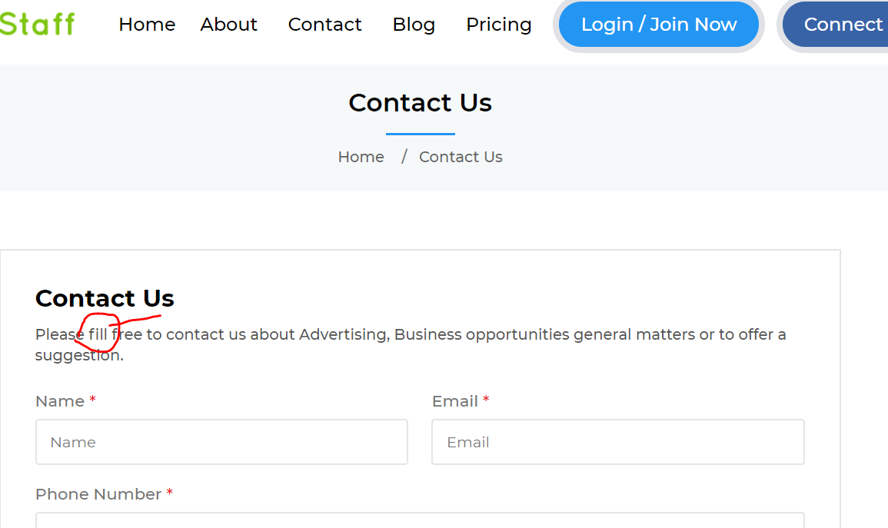

Please can you change the spelling to “feel free” not “fill free”

_________________________________________________________

**About us** (happy with this page no changes needed)

**Find staff updates**

Can you please add in under current location “Avaliable to work from” under “ current location”

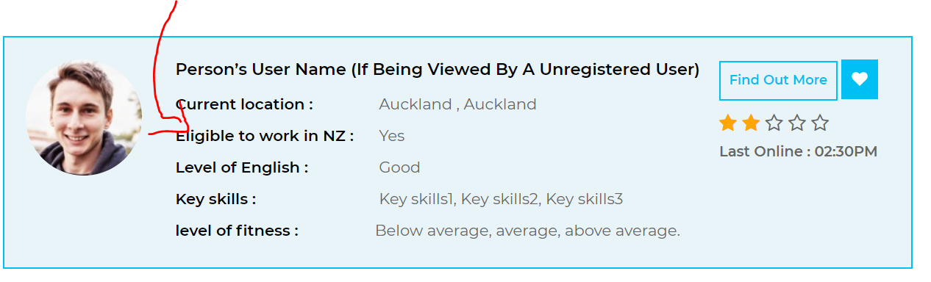

------------------------------------------------------------------

**Find work page updates**

Find work icons need to be “green” not blue.

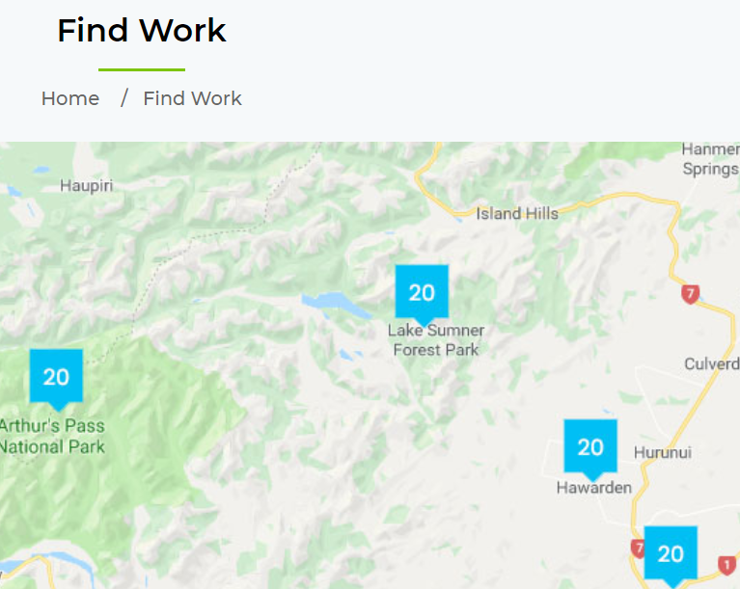

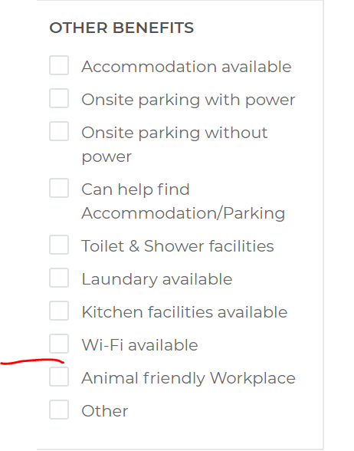

Can you please add “Assistance with transport” between “wifi avaliable and animal friendly”

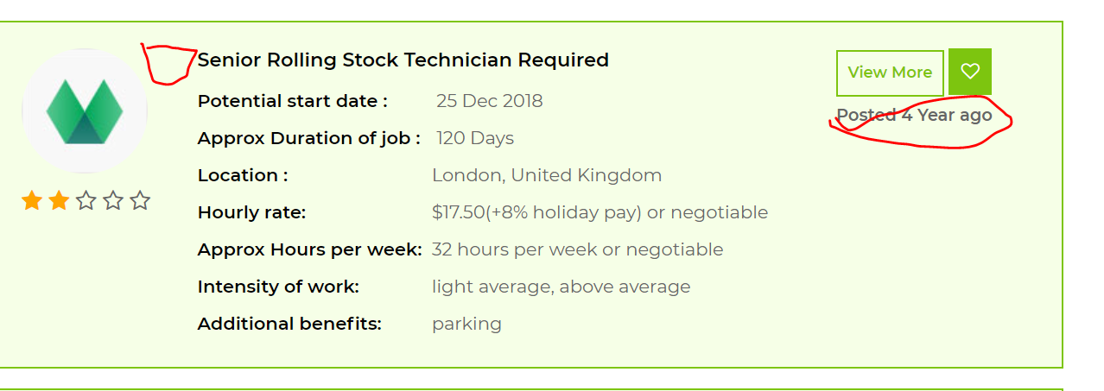

Can you please a beside the job description a box that will display the number of jobs available for that position. Eg 25 Kiwifruit packers (we are needing this so we can understand how many jobs there are in each roll.

Also where it say “posted 4 years ago” can this show when it was last updated instead of posted. Can it say “last updated…..” this is so the people looking for a job can see if it is still relevant.

**Manage applicant update**

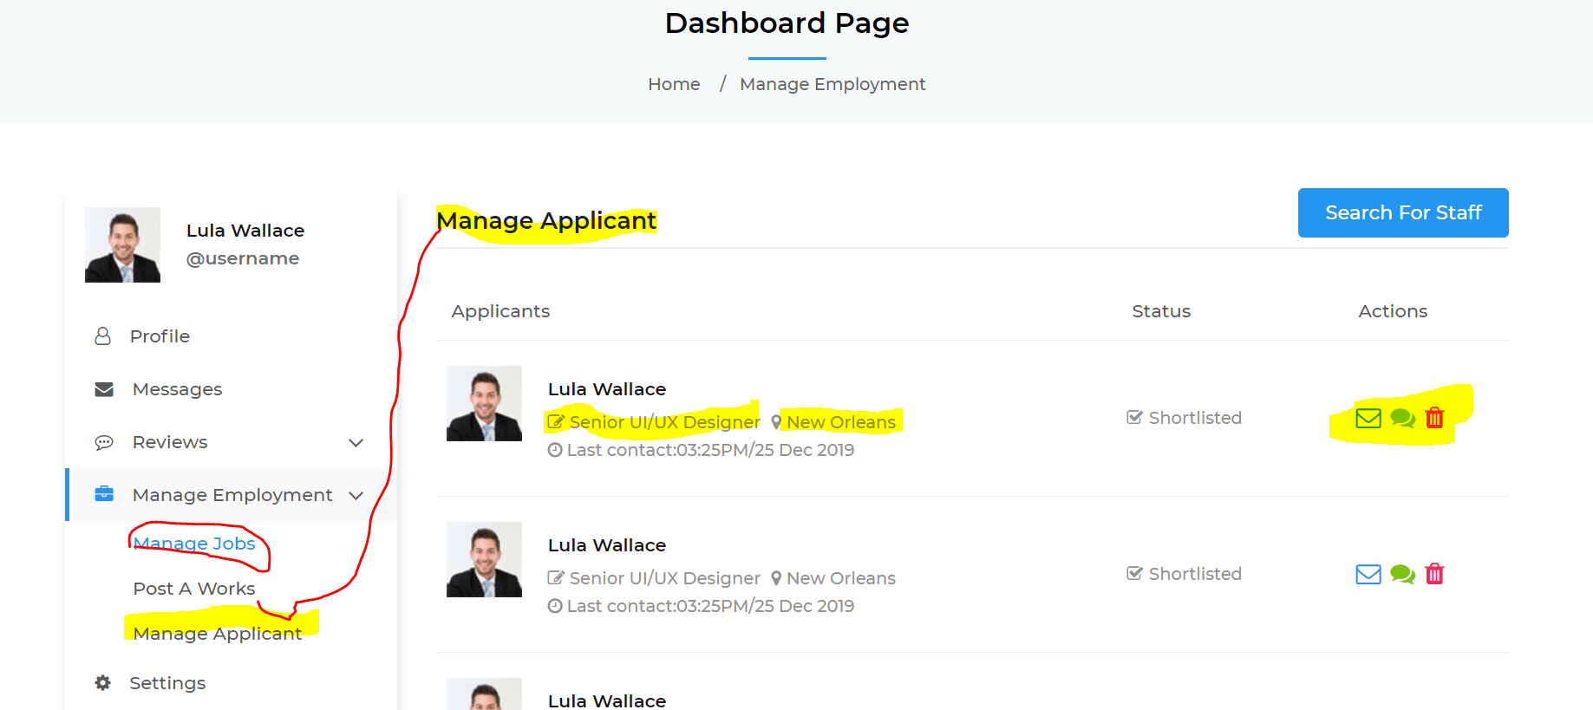

Manage applicant needs to be highlighted in blue because you are on the page, this show “manage jobs” in blue should be “Manage Applicant”in blue.

Under the applicants name you have “Senior UI/UX Designer” please can you remove this as most of the positions that will be advertised on this site are un or low skilled jobs. Instead can you please change this to “Current location …. New Orleans” so that a glance the Employer can see where they are.

On the right hand side is it possible on all pages when you hover over the icon it shows what the action is … eg delete, email etc.

**Jobs message page** – we are happy with this page no changes needed

Seasonal job Profile page updates

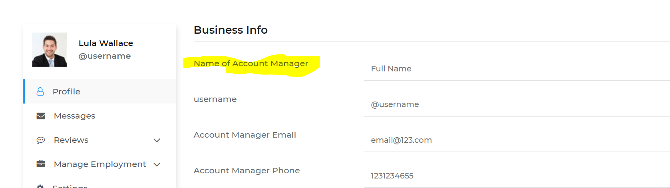

Just to be clear this is the page that the business fill in (this is different to the workers page) Please can their be a field above “Name of Account Manager” that says “Business Name”

Then please change “Name of Account Manager” to “Primary account Manager”

Where is says “ Introduce yourself” please can this say “Tell us abit about your business”

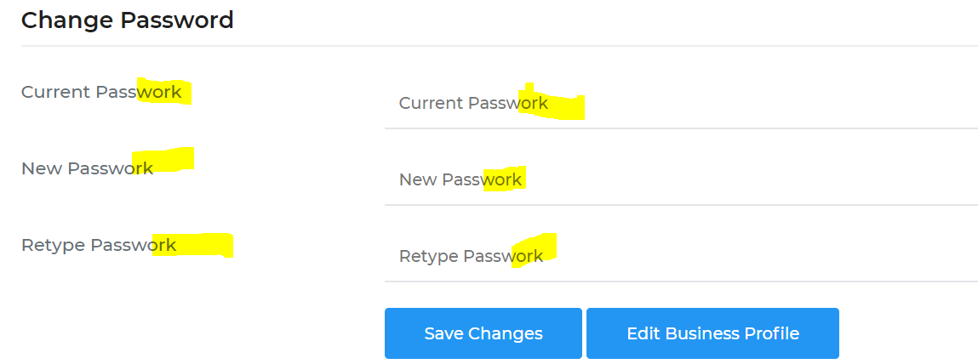

Please can you correct the spelling from “Passwork” to “Password”

**Works applied page updates**

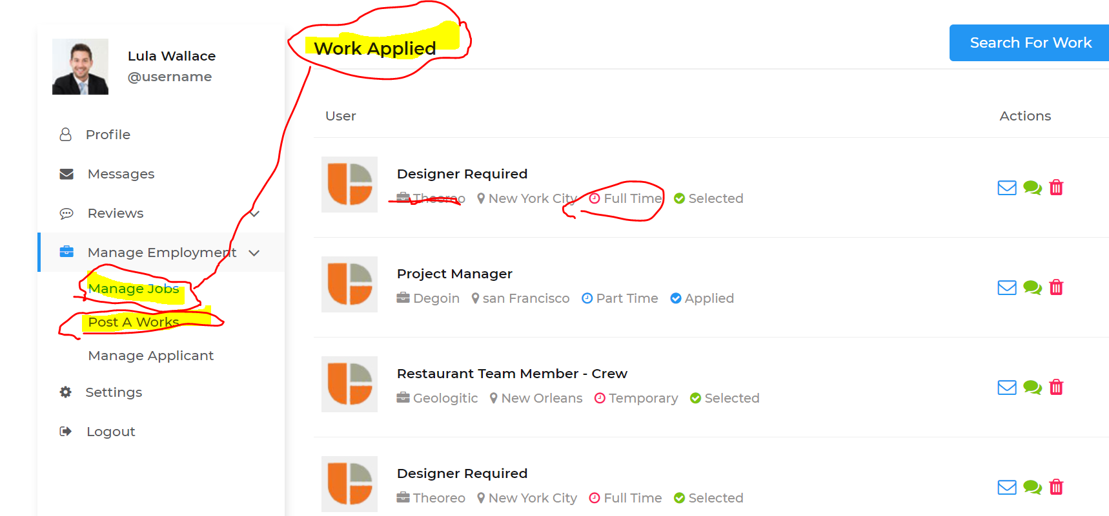

“work applied” should be changed to “Manage Jobs”

Please remove aspect that has red line though it… not sure what that is about. Instead display “location” and then have the location the job is in ..eg New York City

I have circled “Full time” for This needs to align with the “contract type” which is one of the fields we have asked to be added. The field selection will either be “Fixed term” “casual” “contract rate” or “other” (this was on a previous update that we sent back)

**Job work detail page update**

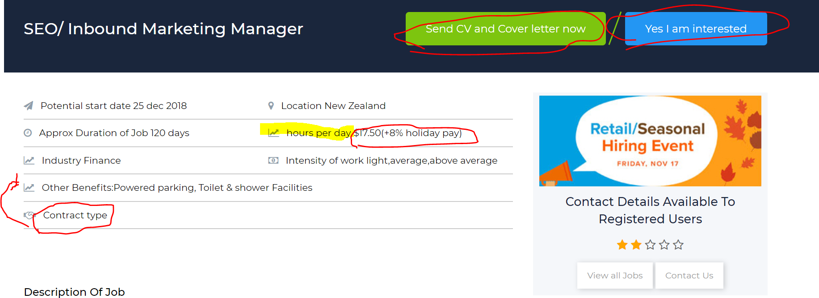

Some of these changes were mentioned on previous updates

Please ensure that “Send CV and Cover letter now” and “Yes I am interested” are either or on display. The employer would select how they wanted to have applications come through. Only one would display and they would select this when they were creating the advert.

Hours per day…. Would be a range (this was mentioned in a previous update) 0-4 hours per day, 4-8 hours per day 8 or above hours per day. (Hours per day would not hav an hourly rate.)

You also need to have “Hourly rate” which would display $17.50 + 8% for example or negotiable. This is in the preivew part but not mentioned here. (please ensure all of these match up)

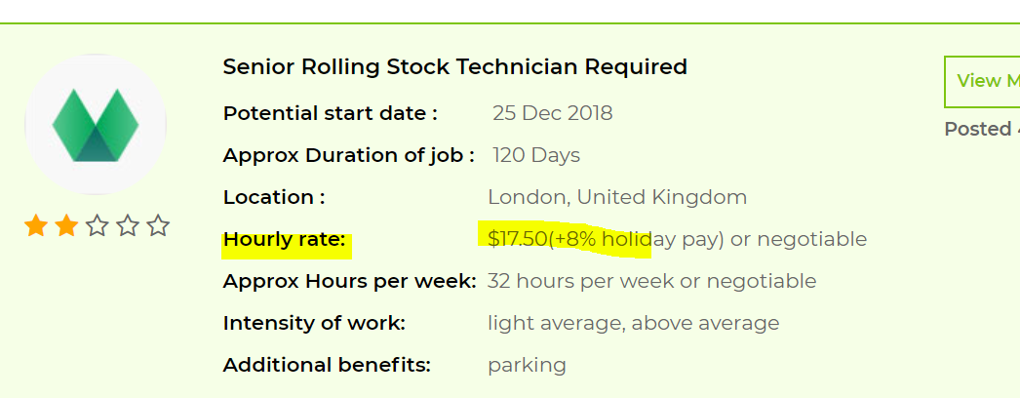

Please move “contract type” above “other benefits”

**Post a review page update.**

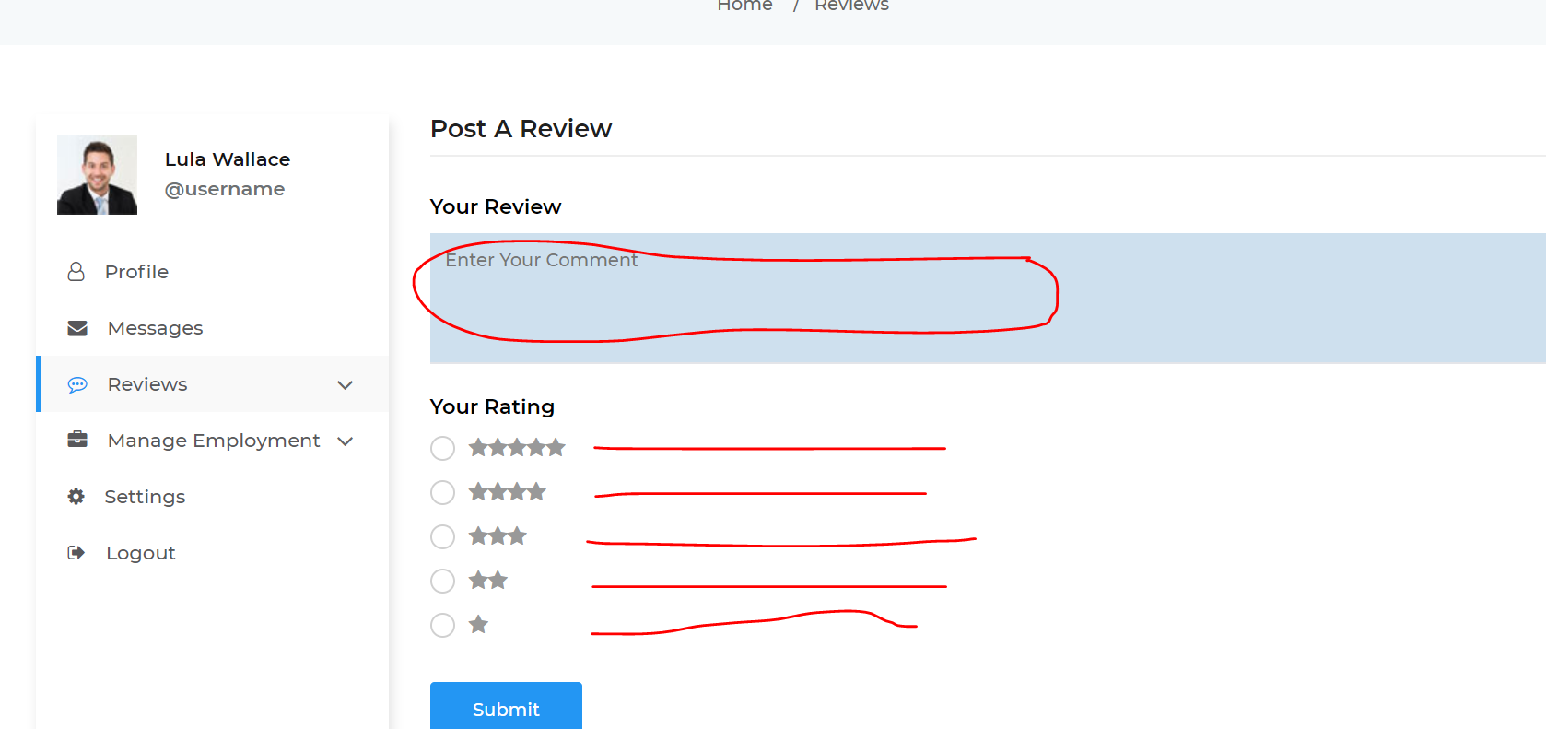

Can the review “comments” not be published and able to be viewed by the publice. We would like the comments to go straight back to the Employer or the Employee who the review was done on. As admin we would also like to be able to reivew all the comments that are posted.

Beside each star can the following explanation be put. (rating for Employer) could the explatioin be on a drop down list. (so is hidden with an arrow)

For Employer

5 Stars: Exceptional

The workers experience and Businesses facilities far exceeded expectations. Employer has given significant thought to the wellness and comfort of their staff. The worker fully understood what was expected of them and the work that was required to be done was fair and reasonable. The payment that was offered for the position was fair and reasonable and the Employer / Owner / Manager often showed the worker appreciation. The workplace atmosphere and culture was enjoyable and consistent with the company values. The worker felt they were inducted well into their positon and felt valued and safe. Worker highly recommends this Employer to other seasonal workers.

4 stars: Exceeds expectations

The workers experience and facilities at this business was better than they thought they would have been. Employer has considered the wellness and comfort of their staff. The worker knew what was required of them and the work that was required to be done was reasonable. The payment that was offered for the position was as agreed and the Employer / Owner / Manager showed appreciation. The workplace atmosphere and culture was pleasant and consistent with the company values. The worker felt safe. Worker would recommend this Employer to other seasonal workers.

3 starts: Meets expectations

The workers experience and facilities at this business were as they expected them to be. Employer met all their legal obligations and the employee was treated fairly .The worker knew what work was required to be done. The payment that was offered for the position was as agreed. The other workers and the atmosphere was pleasant. The culture was tolerable and consistent with the Business / Owner / Managers values. The worker felt safe. Worker would recommend this Employer to other seasonal workers.

2 stars: Improvement needed

The workers experience and facilities at this business were below what they expected them to be. Employer met all their legal obligations. The Business Owner or Manager was disorganised and the worker sometimes did not know what was expected of them. The people, culture and atmosphere of this Business was satisfactory. Worker would recommend this business but not as a first choice.

1 star: Unsatisfactory

The workers experience was extremely poor at the business. The Employee felt the Employer did not met all their legal obligations and Employee does not think they was treated fairly. The Business Owner or Manager was disorganised and the worker did not know what was expected of them. The people, culture and atmosphere of this Business was unsatisfactory. Worker not would recommend this business to other seasonal workers.

For Employee rating (as above can it be a drop down explanation.

5 Stars (E): Exceptional

The workers work ethic and honesty exceeded expectations. The worker had excellent timekeeping, showed initiative and was a positive and valued member of the team. Their skills and attributes exceeded the business’s expectations and their ability to quickly learn an unfamiliar task was impressive. The worker was fair and reasonable at all times and there were no employment issues during their time of employment with the business. They were tidy, respectful and safety conscious with all the work resources and tools they were given. This staff member is worth paying a little more for if you can secure and would be an asset to your business. I would have no hesitation in re-employing this staff member, and would highly recommend this staff member to other Employers.

4 stars (EE): Exceeds expectations

The workers work ethic and honesty met expectations. The worker had good timekeeping, showed initiative and was a positive and valued member of the team. Their skills and attributes met the business’s expectations and they learnt unfamiliar task well The worker was fair and reasonable at all times and there were no employment issues during their time of employment with the business. They were respectful with the work resources and tools they were given. This staff member would be an asset to your business. I would have no hesitation in re-employing this staff member, and would recommend this staff member to other Employers.

3 stars (ME): Meets expectations

The workers work ethic and honesty met expectations. They were are valued member of the team and worked well with only minor issues with time keeping. Their skills and attributes met the business’s expectations and completed new tasks as assigned. The worker was fair and reasonable at all times and there were no employment issues during their time of employment with the business. They were respectful and safety conscious with the work resources and tools they were given to use. This staff member would be a useful member of the team. I would re-employing this staff member and would recommend this staff member to other Employers.

2 stars (I): Improvement needed

The workers skills and attributes were as they were represented and met the business’s expectations. They completed new tasks as assigned. The worker was fair and reasonable with only minor employment issues during their time of employment with the business. They used the work resources and tools they were given in a safe manner. This staff member would be a useful member of the team. I would consider re-employing this staff member and would recommend this staff member to other Employers but not as a first choice.

1 star (U): Unsatisfactory

This workers did not met expectations. This workers productive was below where we would expect it to be, for their age, skill, level of education and training given. Their time keeping, work ethic and personal behaviour was below what the industry expects. Their lack of discipline proved disruptive to the other team members There were employment issues during their time of employment with the business. They used the work resources and tools they were given in an unsafe manner. I would not re-employing this staff member and would not recommend this staff member to other Employers.

--------------------------------------------------------------------------------

Seasonal job review page. Updates

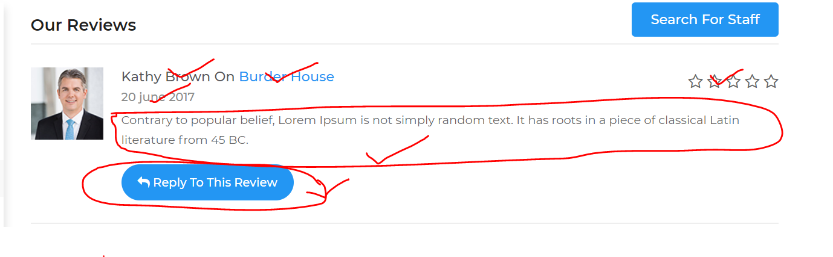

Comments can only be viewed by the recepient not the general public. And the reply to review is only abled to be viewed by the person putting in the comments.

The general public can see the total of the reivews and under the stars show the number of reviews

